Deliverable 3: TO-BE Application Architecture
Company: Aegis Health Partners
The Application Architecture maps the structural design of the new ITAM system. We utilize the C4 Model (Context, Container, and Component levels) to illustrate how systems interact, and Architecture Decision Records (ADRs) to justify the technical choices.
1. C4 Model Diagrams
Level 1: System Context Diagram
This diagram shows the "big picture"—how the Unified ITAM system fits into the Aegis Health Partners ecosystem alongside external SaaS platforms and human actors.

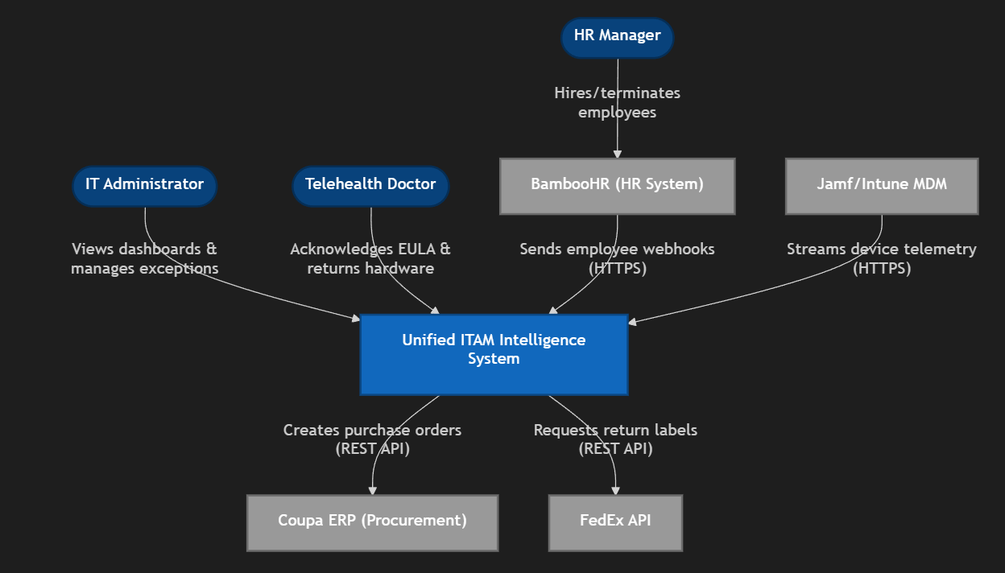

Level 2: Container Diagram
This diagram opens up the "Unified ITAM Intelligence System" box to show the high-level technical containers (microservices, API gateways, and databases) that make it work.

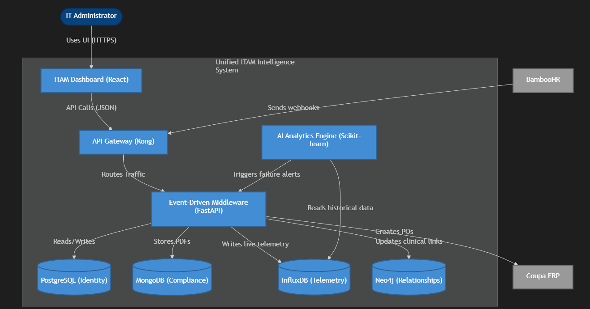

Level 3: Component Diagram (Event-Driven Middleware)
This diagram zooms strictly into the Event-Driven Middleware container to show how the codebase handles incoming data without dropping payloads.

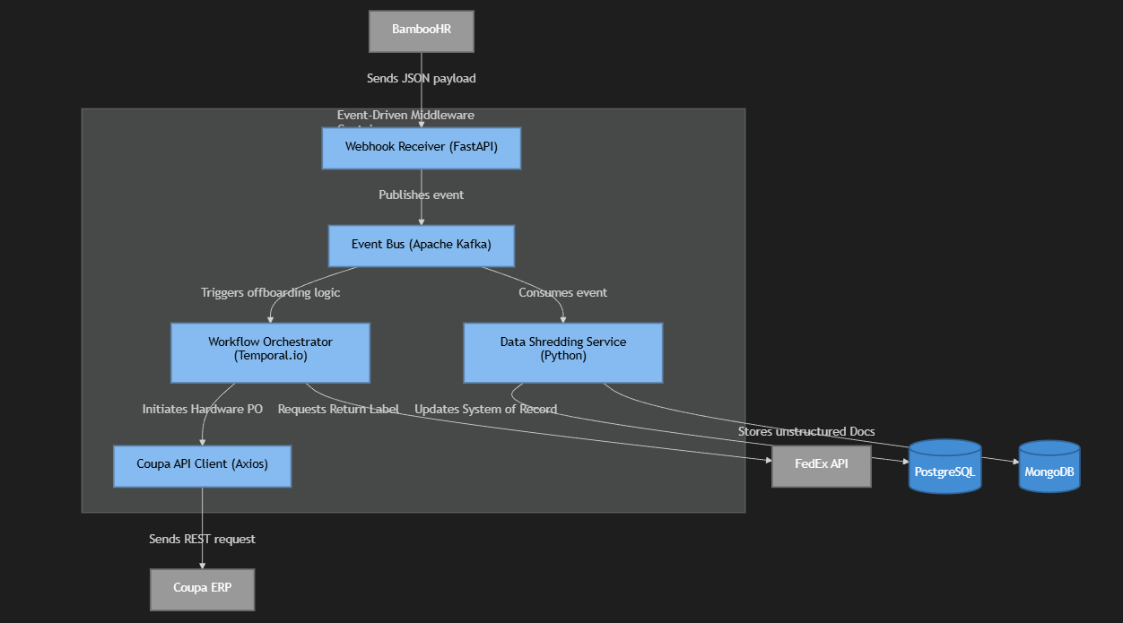

2. Architecture Decision Records (ADRs)
To justify the technical choices made in the C4 models, we formally document the following decisions:
ADR 001: Implement Polyglot Persistence instead of Monolithic SQL
- Context: Aegis requires the storage of heavy compliance PDFs (ePHI Wipe Certificates) and high-velocity telemetry (MDM battery cycles). Storing these in Snipe-IT's core Postgres database will cause locking and degrade application performance.
- Decision: Implement a Polyglot Persistence layer utilizing PostgreSQL (Relational), MongoDB (Document), InfluxDB (Time-Series), and Neo4j (Graph).
- Consequences: This increases the deployment and infrastructure complexity. However, it ensures HIPAA audit queries are instantly retrievable and AI models can query time-series data without crashing the primary inventory database.
ADR 002: Utilize Event-Driven Architecture (Kafka) for Interoperability
- Context: Webhooks from BambooHR and the MDM arrive at unpredictable volumes, especially during mass doctor onboarding/offboarding phases.
- Decision: Introduce an API Gateway and an Apache Kafka event bus to buffer and route messages asynchronously.
- Consequences: If the Snipe-IT database goes offline for maintenance, incoming HR events are safely queued in Kafka and processed later, ensuring zero data loss during clinical logistics flows.
ADR 003: Utilize Temporal.io for Long-Running Logistics Workflows
- Context: Offboarding a remote doctor takes days. The system must "sleep" while waiting for the doctor to ship the physical FedEx box and wake up to check the tracking status. Standard cron jobs are difficult to scale and monitor for this purpose.
- Decision: Use Temporal.io to manage stateful, long-running offboarding workflows.
- Consequences: Eliminates manual follow-up emails from IT staff. The system natively handles retries, timeouts, and automated escalations (like triggering a payroll deduction hold) if the hardware remains unreturned after 14 days.

